Name:  
Mark all pentominoes which are the unfolding of an empty box: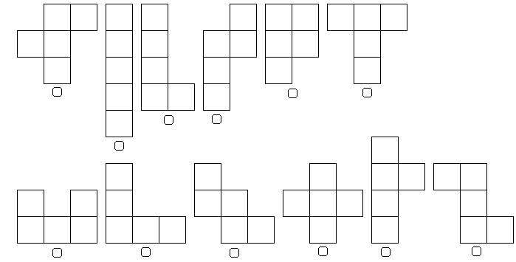

Name:  
Mark all hexominoes which are the unfolding of a cube:  
