“The year of the OX”
U |  |  |  |  |  |  |  |  | N
N
 |  |  | F |  |  |  | F
 |  |  |  |  |  |  |  |  |  |  | X
Divide the grid (white squares) into pentominoes so that no two pentominoes of the same shape (including rotations/reflections-same colour) share an edge. A cell with a letter in it must be part of the pentomino shape normally associated with that letter.
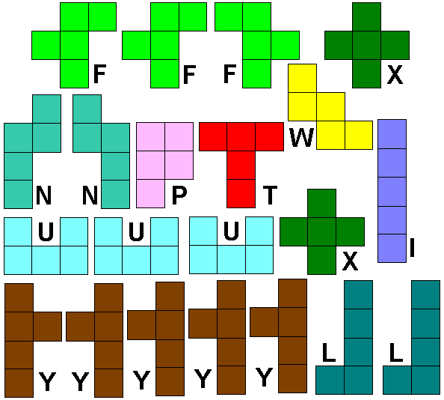
You can fill in the cells in the table and draw your solution.
Send to OdetteDM@outlook.com

